

**CPISM PROJECT**

# 



**MOUNTAINERING**

GROUP MEMBERS:

* ANAS KHALID(student1525226)
* ABDUL GHANI (Student1526983)

0

ACKNOWLEDGMENT 2

CERTIFICATE OF COMPLETION 3

PROBLEM STATEMENT 4

HOME PAGE 6

SCREEN SHOTS 6

REGISTRATION FORM 8

WORK BREAKDOWN CHART 13

CONCLUSION 14

TABLE OF CONTENT

# ACKNOWLEDGMENT

I would like to express my very great appreciation to **SIR MAAZ**for his valuable and constructive suggestions during the planning and preparation of our project. His willingness to give his time so generously has been very much appreciated.

I would also like to thankfull the staff of **APTECH METRO STARGATE**that they give me the permission to visit their offices to solve my problem.



**THIS IS TO CERTIFY THAT**

# CERTIFICATE

# OF

# COMPLETION

CERTIFICATE OF

COMPLETION

**HAS COMPLETED TO ALL THE REQUIRED STATEMENT AT THE PROJECT**

**DATE**

**Anas Khalid ,Abdul ghani**

24-10-2022



**SIGNATURE**

# PROBLEM STATEMENT

Mountain agencies encounter several interconnected challenges that impede their operations and jeopardize the safety of both staff and tourists. These challenges include:

**Customer Expectation:**

1. **Limited Resources**: Mountain agencies often operate with limited funding, personnel, and equipment, hindering their ability to respond effectively to emergencies, maintain infrastructure, and conduct necessary patrols and inspections.
2. **Harsh Environmental Conditions**: Mountainous terrain presents harsh weather conditions, rugged landscapes, and high altitudes, which can make operations difficult and dangerous for agency personnel. Extreme weather events, such as avalanches, landslides, and flash floods, further exacerbate these challenges.
3. **Safety Risks and Accidents**: Staff and tourists face various safety risks in mountainous regions, including falls, altitude sickness, exposure to extreme temperatures, and encounters with wildlife. Inadequate safety protocols, training, and equipment increase the likelihood of accidents and injuries.
4. **Communication and Connectivity Issues**: Remote locations and rugged terrain often result in poor communication and limited access to modern technologies, such as cellular networks and internet connectivity, impeding coordination among agency personnel and emergency response efforts.
5. **Environmental Conservation and Sustainability**: Mountain ecosystems are sensitive environments that face threats from climate change, deforestation, pollution, and unsustainable tourism practices. Balancing the needs of tourism, conservation, and local communities while mitigating environmental degradation poses significant challenges for mountain agencies.
6. **Lack of Standardization and Coordination**: There is often a lack of standardized protocols, interoperable communication systems, and coordinated efforts among different agencies involved in mountain management and emergency response, leading to inefficiencies and gaps in service delivery.
7. **Community Engagement and Empowerment**: Building trust and collaboration with local communities is essential for the success of mountain agencies. However, cultural differences, language barriers, and socioeconomic disparities can hinder effective community engagement and empowerment initiatives.
8. **Data Management and Analysis**: Effective decision-making in mountain management requires access to timely and accurate data on weather patterns, environmental changes, visitor demographics, and incident reports. However, many mountain agencies lack robust data management systems and analytical capabilities.

Addressing these challenges requires a comprehensive approach that involves improving resource allocation, enhancing staff training and safety protocols, investing in appropriate technology and infrastructure, fostering collaboration among stakeholders, and promoting sustainable practices that prioritize both conservation and community well-being. By addressing these challenges, mountain agencies can fulfill their mission more effectively and ensure the safety and enjoyment of visitors to mountainous regions while preserving these unique environments for future generations.

***Home page of our project***

# SCREEN SHOTS

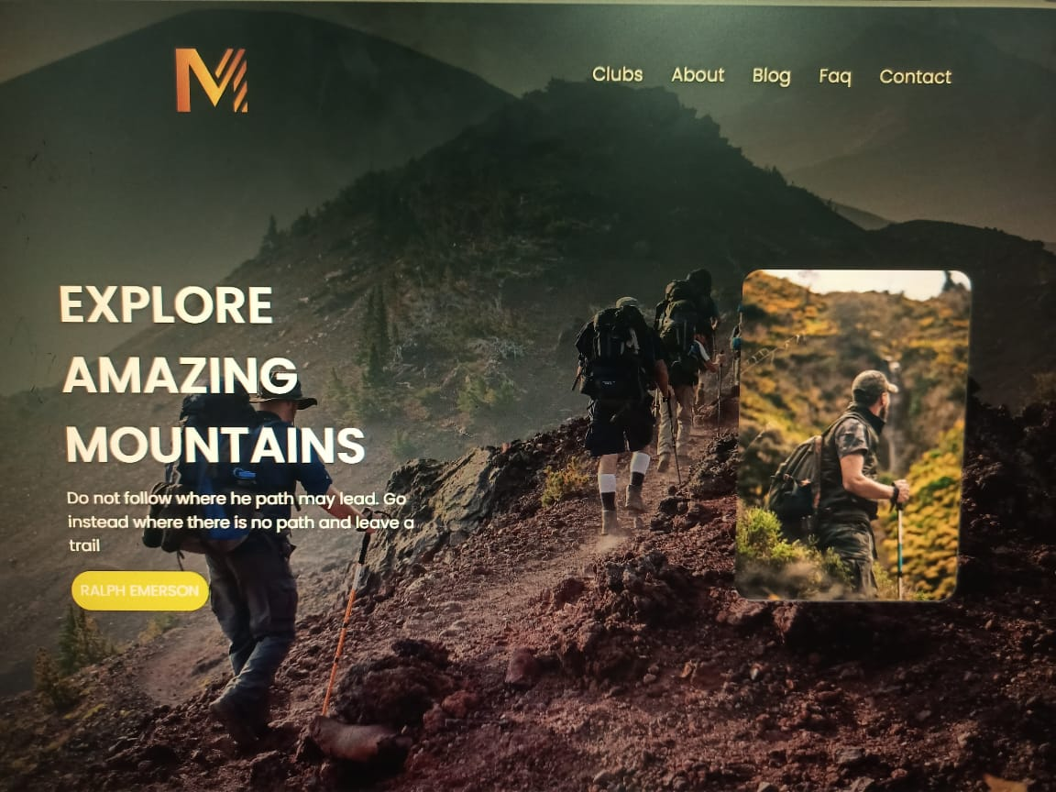

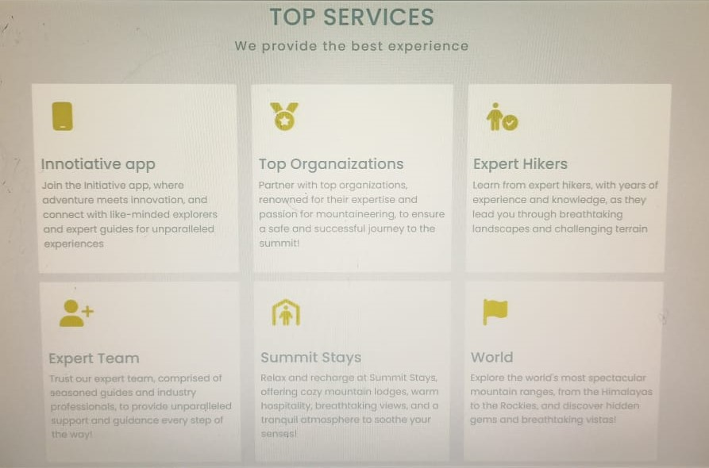

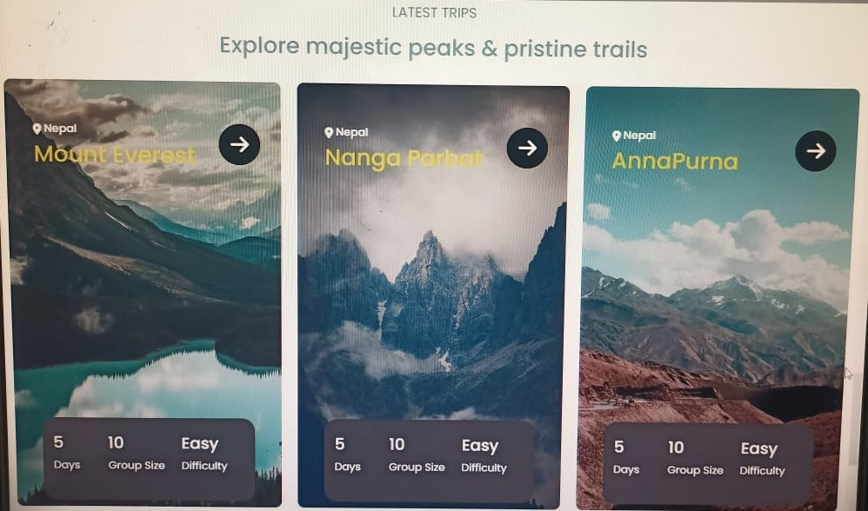

***Footer***

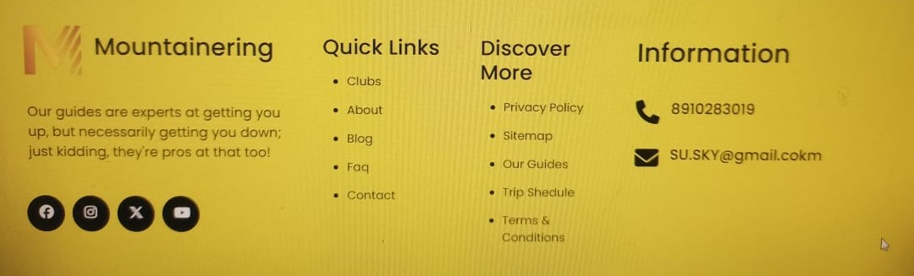



***Pages***





***Contact us page***



***Players info***



# WORK BREAKDOWN CHART

Khurram ,Hassan,Alishba

ANALYSIS

6 DAYS

|  |  |  |
| --- | --- | --- |
| **PHASES** | **TIME IN DAYS** | **TEAM MEMBERS** |
|  |  |  |
|  |  |  |
|  |  |  |
|  |  |  |
|  |  |  |

Khurram ,Hassan,Alishba

Khurram,Hassan

Alishba,khurram

Khurram ,Hassan,Alishba

10DAYS

4 DAYS

5DAYS

5 DAYS

IMPLEMENTATION

TESTING

DESIGNING

PLAINING

*OUR WEBSITE “SPORTSINFO”IS ONE OF THE BEST WEBSITE FOR SPORTS FANS “SPORTSINFO” HAS A AMAZING STYLE FOR ITS HOME PAGE. THE MAIN NAVIGATION INCLUDES LINKS TO EACH OF SPORTS GAMES.THE WEBSITE INCLUDES AMAZING INFORMATION AND HISTORY ABOUT DIFFERENT SPORTS AS WELL AS ALL KINDS OF CONTENT FOR SUCH AS TOURNAMENT EVENTS, CHAMPIONSHIPS AND INCLUDES INFORMATION ABOUT FAMOUS SPORTSMAN CAREER AND LIFE*

*HOPE OUR WEBSITE HELP YOU!!!*

# CONCLUSION